Where can I find some free sprite sheets that are space-ship like.

2 𝕏 posts


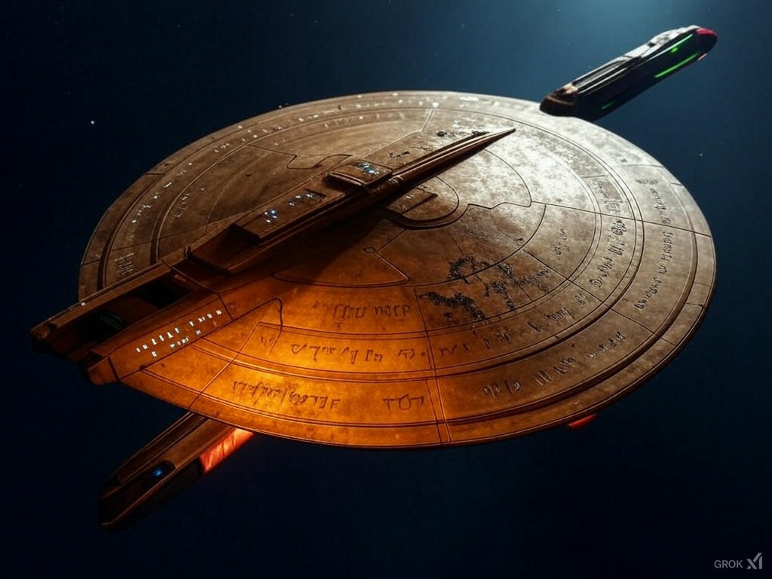
shields failing dramatically

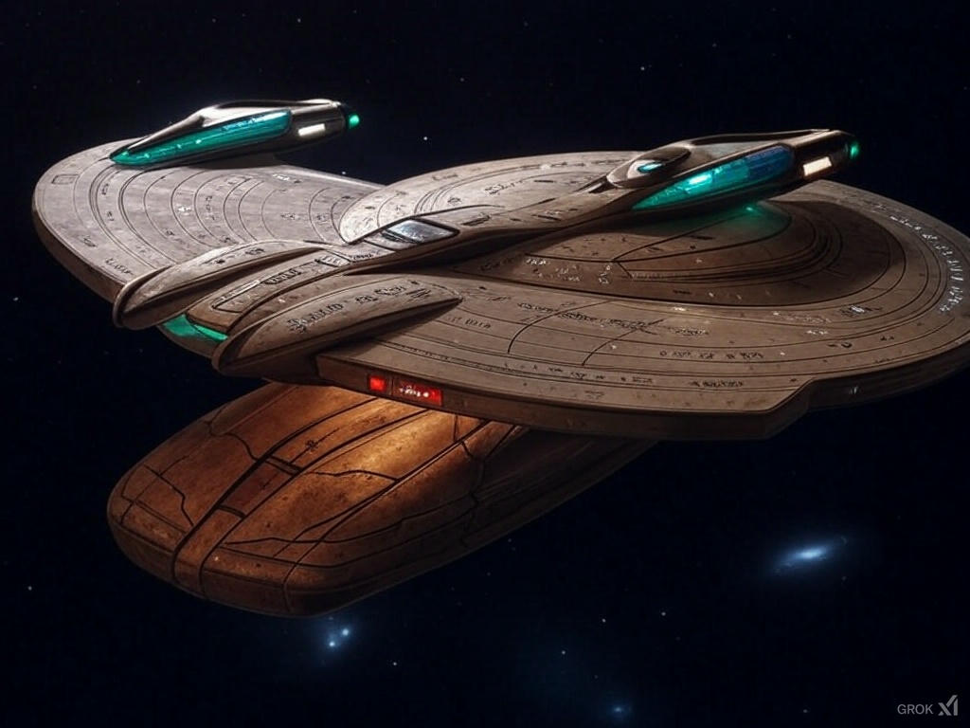

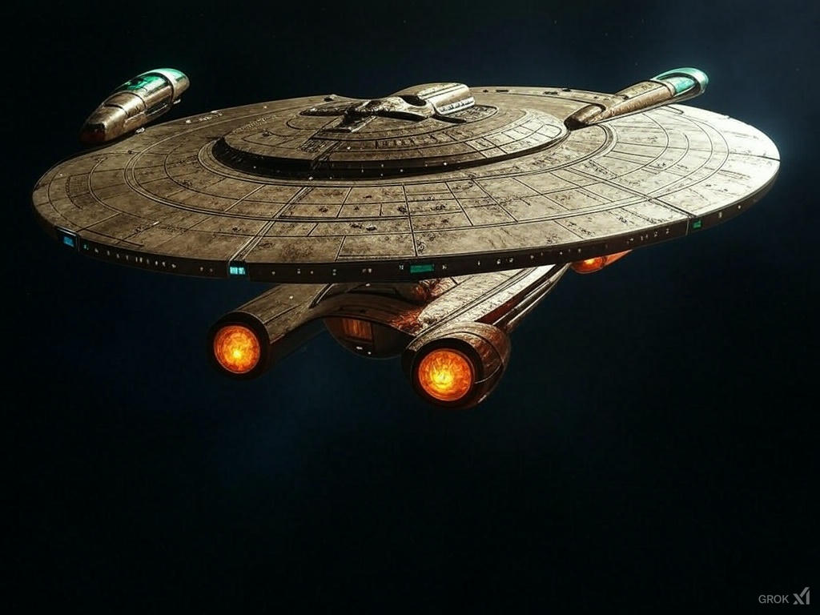
could you load it with equipment like the milenium falcon? Satellite dishes, scanners, etc.?
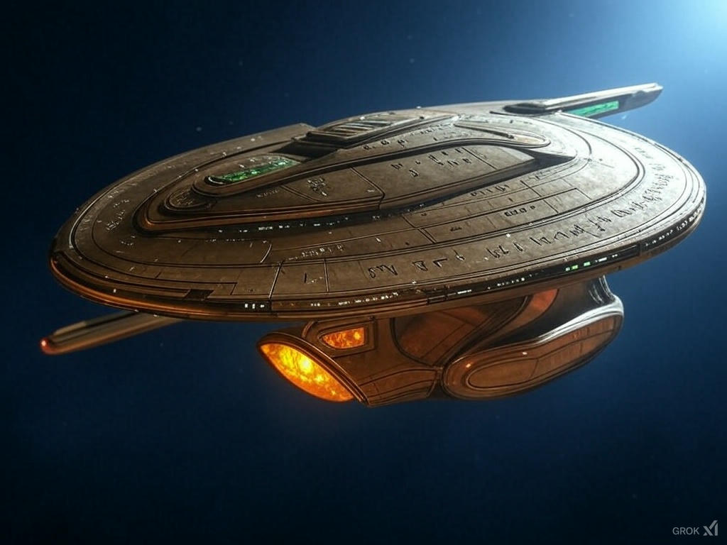

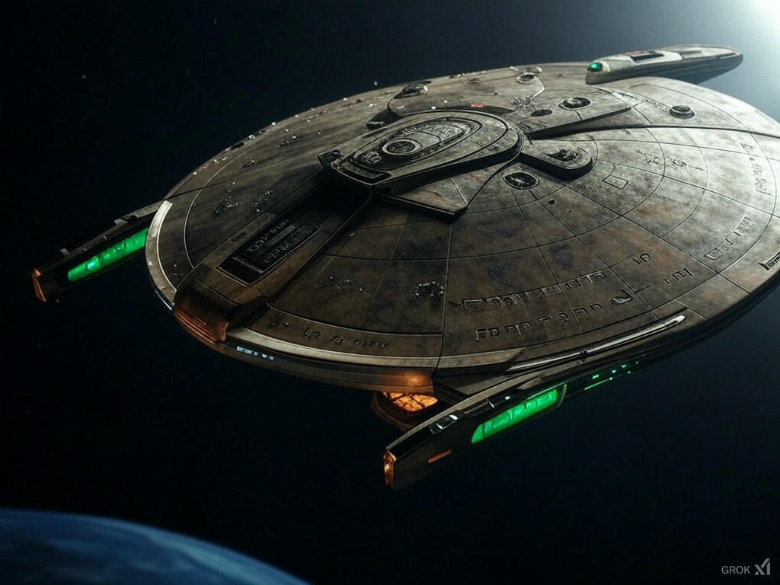

Ok, the one on the right is awesome. Now can you show me what the engine room might look like from the top down or so?

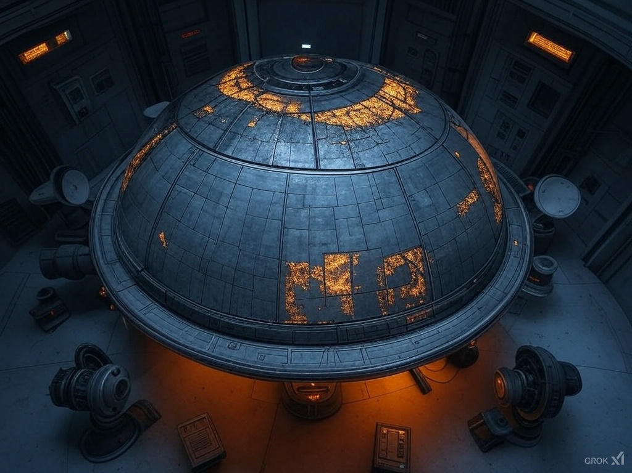
with glowing conduits

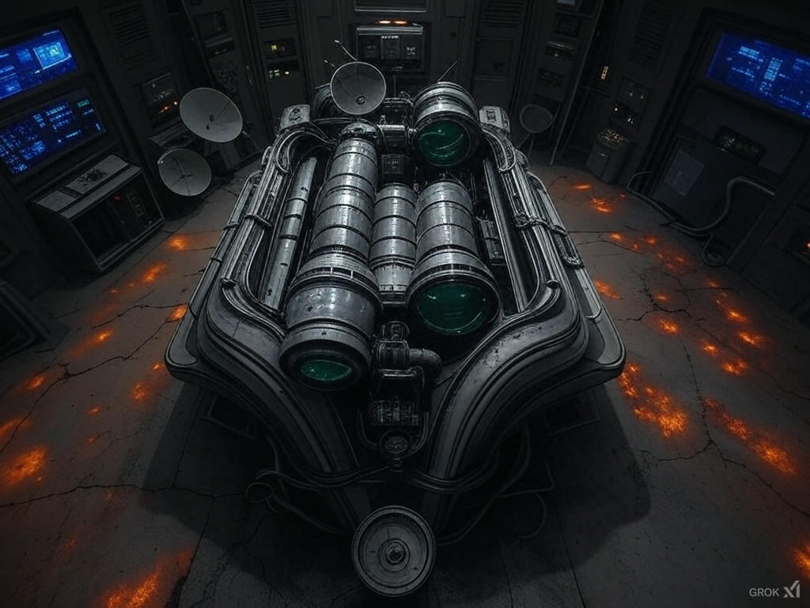

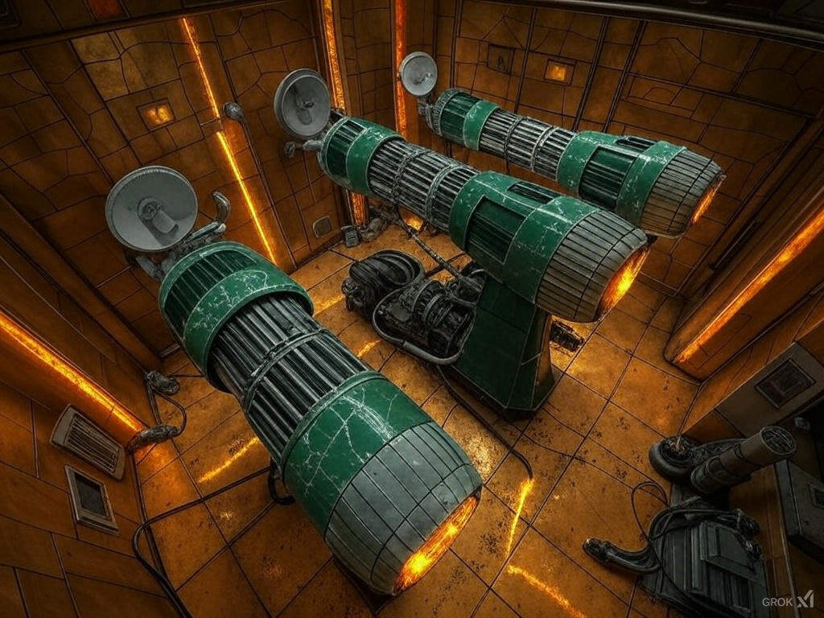

with radiant circuits

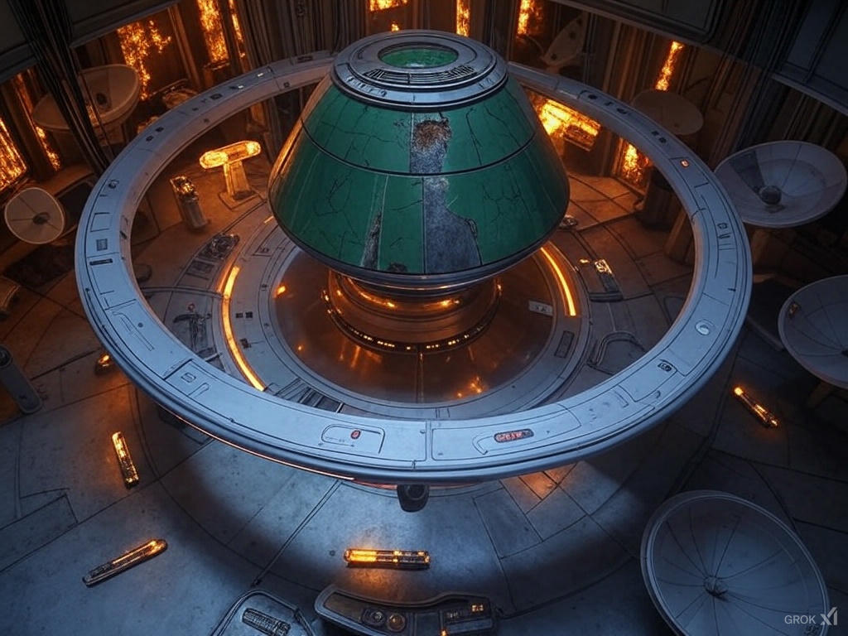

OK, now put a bunch of repair junk around like an oscilliscope and things. Kindof like an electrical engineer's desk.
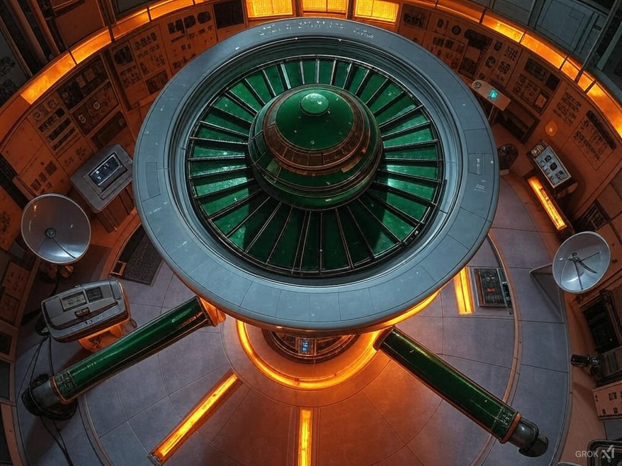

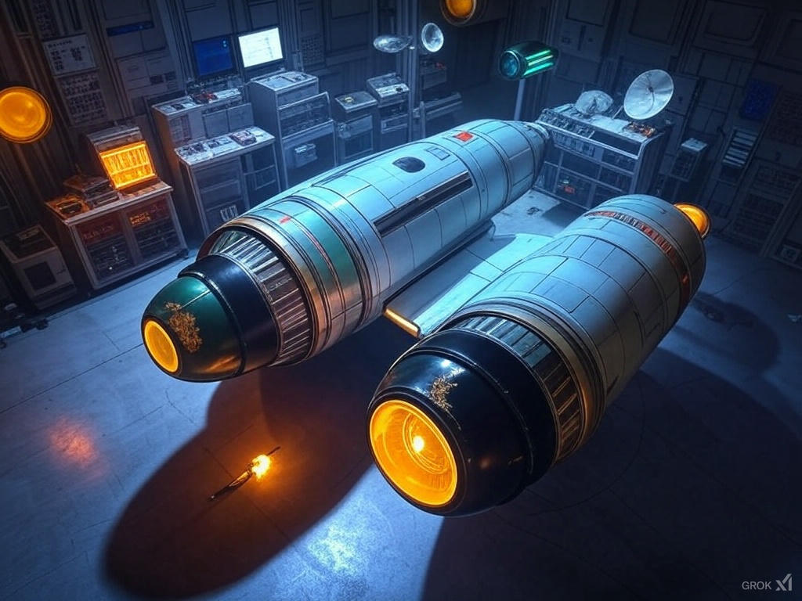

OK, for the outside view of the ship, how do I get started in say godot and blender?
Creating the outside view of your starship—let’s call it the Saul’s Vanguard with its bronze hull, corrosive emerald engines, amber weapons, failing shields, and Millennium Falcon-style gear—involves two main steps: modeling and texturing it in Blender, then importing and setting it up in Godot for that Starfleet Command-style 3D top-down diagonal view. Since you’re starting fresh, I’ll keep it beginner-friendly and focused on your vision. Let’s break it down.

Step 1: Modeling in Blender
Blender’s free, powerful, and perfect for your ship. Here’s how to get started:

Setup
- Download Blender: Grab it from blender.org (version 4.0 or later as of Feb 2025). Install and open it.
- Interface Basics: You’ll see a cube in a 3D viewport. Use the mouse wheel to zoom, middle-click-drag to orbit, and Shift+middle-click-drag to pan. Hit Numpad 7 for a top-down view to match your game’s vibe.

Rough Ship Shape
- Base Saucer:
  - Select the default cube (right-click), hit Tab to enter Edit Mode.
  - Press S then X and drag to scale it wide (like a saucer), then S+Y for depth. Keep it flat with minimal Z scaling.
  - In Edit Mode, hit Ctrl+R, hover over the top face, click once, then drag to add edge loops. This lets you tweak it into an angular, bronze-age shape later.
- Secondary Hull (Spear Tail):
  - Add a new cube (Shift+A > Mesh > Cube), position it below the saucer (G+Z), and scale it long and thin (S+Y) like a chariot yoke or spear.
  - Merge it into the saucer by selecting both (Shift+right-click), then Ctrl+J to join them into one object.
- Nacelles:
  - Add two cylinders (Shift+A > Mesh > Cylinder), scale them (S), and move them to the sides (G+X). Tilt them back (R+X`) like wings for that predatory look.
  - Extrude the ends (E) to make them spear-like, matching Saul’s warrior vibe.

Details
- Damage: In Edit Mode, select faces (3 key for face mode), hit Ctrl+T to triangulate, then Alt+J to clean up quads. Use the Knife tool (K) to cut cracks, then G to pull vertices for dents.
- Equipment: Add simple shapes—cube for a scanner, cone for a dish (Shift+A > Mesh > Cone)—and scatter them on top. Scale and rotate (S, R) for that cluttered Falcon feel.
- Angle It: Rotate the whole model (R+X+45) to preview that diagonal view.

Texturing (Basic)
- UV Unwrap: In Edit Mode, select all (A), hit U > Smart UV Project. This flattens your model for painting.
- Materials:
  - In the Material Properties tab (bottom-right sphere icon), click “New.” Name it “Bronze.”
  - Set Base Color to a dark bronze (#8C5523). Add a Metallic value (0.8) and Roughness (0.4) for that hammered look.
  - Add a second material for engines, set Base Color to toxic green (#00FF66), and crank Emission to 1.0 for a corrosive glow.
  - Add a third for weapons, Base Color amber (#FFBF00), with slight Emission (0.5).
- Assign: In Edit Mode, select nacelle faces, click the green material, and hit “Assign.” Repeat for weapons.

Export
- Select your ship, go File > Export > glTF 2.0 (.glb). Save it as “SaulsVanguard.glb.” This format plays nice with Godot.
Time: 5-10 hours for a rough version if you’re new. Watch a Blender beginner tutorial (e.g., Blender Guru’s donut) for basics.

Step 2: Setting Up in Godot
Godot’s a free game engine that can handle your 3D top-down view. Here’s how to bring your ship to life:

Setup
- Download Godot: Get it from godotengine.org (4.2 or later as of Feb 2025). Open it and create a new project (“SaulsVanguardGame”).
- Scene Basics: Start with a 3D scene (+ > Node3D). This is your root.

Import Ship
- Drag “SaulsVanguard.glb” into your project’s file system (bottom-left).
- Add it to the scene: + > MeshInstance3D, click its Mesh property, and pick your .glb file. It’ll appear in the 3D viewport.

Camera Angle
- Add a Camera3D (+ > Camera3D). Position it above and behind the ship (G+Z+10, G+Y+-5).
- Rotate it down 45° (R+X+-45) for that Starfleet Command diagonal view. Use the preview (top-right corner) to tweak.

Shields & Effects
- Shields: Add a MeshInstance3D, use a Sphere mesh, scale it to fit the ship. In its material, set Albedo to amber (#FFBF00), Transparency to 0.5, and toggle “Unshaded” for a glow. Animate it flickering:
  - Add an AnimationPlayer node, create a new animation (“ShieldFail”), keyframe the Transparency from 0.5 to 0.1 over 1 second, loop it.
- Damage: For now, rely on your Blender damage. Later, swap meshes in Godot for worse states.

Test It
- Hit F5 to run. Use WASD or a simple script to move the ship (Node3D > func _process(delta): translate(Vector3(Input.get_axis("ui_left", "ui_right"), 0, Input.get_axis("ui_up", "ui_down")) * delta * 5)). Does it feel alive?
Time: 2-5 hours to get it moving, more for effects.

Next Steps
- Polish in Blender: Add rivets, runes, more gear. Sculpt damage deeper. Paint textures in Blender or Substance for grit.
- Godot Gameplay: Script shield health (decrease on “hit,” flicker faster), add enemy shots (ParticleSystem3D), and test upgrades (swap meshes).
- Learn as You Go: Blender’s UI is a beast—focus on one tool at a time (e.g., extrude, scale). Godot’s nodes click fast once you grasp them.
You’ve got a ship with bronze grit, emerald engines, amber weaponry, and a battle-worn soul. Start with the saucer in Blender, import it to Godot, and tweak that camera. What part sounds most fun to tackle first—modeling the hull or setting up the scene? I can dive deeper wherever you point!
How can Grok help?
DeepSearchThink
Grok 3



20 web pages
If you're looking for free spaceship-themed sprite sheets, there are several great resources online where you can find high-quality assets for your projects. Here are some options based on widely available sources:
- OpenGameArt.org
This is a popular hub for free game assets. You can find spaceship sprite sheets like the "Space ship sprite sheet" by user "manwesulimo2004," which includes around 30 spaceship designs created with GIMP, ideal for side-scrolling shooters. Another option is the "Animated spaceships" pack, featuring 8 32x32 sprites, 7 of which are animated. Just search for "spaceship sprite" on their site to explore more.
- Itch.io
Itch.io hosts a variety of free game assets tagged with "spaceship" and "sprites." For example, you can find "Free Enemy Spaceship 2D Sprites Pixel Art" by CraftPix, which includes 6 pixel-art ships with animations for shooting, damage, and explosion. There’s also the "Void - Main Ship" asset by Foozle, featuring a spaceship with animated engines, shields, and weapons. Use the tags "spaceship" and "sprites" to filter free downloads.
- CraftPix.net
CraftPix offers free pixel-art sprite sheets, including their "Free Spaceship Pixel Art Sprite Sheets," which feature 3 spaceships with motion animations. These are designed for easy editing in tools like Photoshop and integration into game engines like Unity or GameMaker.
- Kenney.nl
Kenney provides public domain assets, including the "Simple Space" 2D pack, which contains spaceship sprites among other space-themed graphics. These come with vector source files and sprite sheets in PNG format, available in two sizes. Check their website under the assets section.
- MillionthVector Blog
This site offers free spaceship sprites under a Creative Commons license (with credit required). You’ll find various designs, often created with Blender3D or Krita, suitable for games like space shooters or strategy titles. Look for the "Free Sprites" section.
These resources are free to use, though some may require attribution—always check the licensing details on each site. If you need something specific (e.g., size, style, or animation type), let me know, and I can refine the suggestions!
How difficult is it to make the art for a game like starfleet command (3D top diagonally down)?
Creating art for a game like Starfleet Command—which uses a 3D top-down diagonal (isometric-like) perspective—can range from moderately challenging to highly complex, depending on your goals, tools, and experience level. Let’s break it down based on the key factors: art style, technical requirements, and production scope.

1. Art Style and Complexity
Starfleet Command features 3D spaceship models rendered in a pseudo-isometric view, with detailed textures, lighting, and animations (e.g., weapon effects, damage states). The difficulty depends on how closely you want to match that aesthetic:
- Low-Poly Simplistic Models: If you go for a minimalist, low-polygon look (e.g., basic shapes with flat textures), this is relatively easy. Tools like Blender (free) can handle this, and you’d spend more time learning modeling basics (e.g., extruding shapes, UV mapping) than perfecting intricate details. Expect 5-20 hours per ship for a beginner, less with practice.
- Detailed Realism (Starfleet Command Level): The game’s ships have moderate polygon counts, detailed textures (e.g., hull patterns, glow effects), and animations. This requires proficiency in 3D modeling, texturing, and rigging. A single ship could take 20-50 hours for a novice, including sculpting, retopology, baking normals, and painting textures in tools like Substance Painter or Photoshop.
- Effects and UI: Beyond ships, you’d need weapon effects (lasers, explosions), backgrounds (space, nebulae), and a functional UI. Particle systems (e.g., in Unity/Unreal) for effects add moderate complexity, while space backdrops can be simple 2D art or 3D skyboxes.

2. Technical Skills Required
- 3D Modeling: You’ll need to create 3D assets using software like Blender, Maya, or 3ds Max. For a top-down diagonal view, you model ships in full 3D but optimize them for a fixed camera angle, reducing unseen detail (e.g., undersides). Learning curve: steep if you’re new, manageable if you’ve modeled before.
- Texturing: UV unwrapping and creating diffuse, normal, and specular maps are essential for that sci-fi look. Tools like Substance Designer can streamline this, but mastering them takes time (weeks to months).
- Animation: If ships need thrusters, rotating turrets, or damage states, you’ll rig and animate them. Basic keyframe animation is straightforward; complex sequences (e.g., scripted damage) are harder.
- Rendering: Starfleet Command pre-renders sprites or uses real-time 3D. Real-time (Unity/Unreal) requires shader knowledge and optimization (e.g., LODs, polycount management). Pre-rendering (like older games) needs additional steps to export sprite sheets from 3D renders, adding workflow complexity.

3. Scope and Team Size
- Solo Developer: For one person, a single detailed ship might take days to weeks, depending on skill. A small game with 5-10 ships, basic effects, and a UI could take 3-6 months of part-time work for a beginner, assuming 100-200 hours total on art alone.
- Team Effort: Starfleet Command was built by a studio (Taldren) with dedicated artists. A small indie team (e.g., modeler, texture artist, animator) could produce assets faster, splitting tasks to finish a ship in 1-2 days each.

4. Tools and Learning Curve
- Free Tools: Blender (modeling, animation), GIMP (texturing), Unity (game engine) are free and capable. Tutorials on YouTube or Udemy can teach you spaceship modeling in 10-20 hours.
- Paid Tools: Maya ($1,700/year), Substance Painter ($150/year), or Photoshop ($20/month) speed up professional workflows but aren’t necessary.
- Experience: A beginner might struggle with topology or UV seams initially. With 50-100 hours of practice, you’d reach intermediate competence for game-ready assets.

5. Comparison to 2D Art
Compared to 2D sprite sheets (like those I mentioned earlier), 3D art for this perspective is harder due to the added dimension and technical pipeline. A 2D spaceship sprite might take 2-5 hours in Pixelmator or Aseprite, while a 3D equivalent takes 10-50 hours due to modeling, texturing, and rendering steps.

Effort Estimate
- Minimalist Game: 5 low-poly ships, basic textures, simple effects—50-100 hours total (~1-2 months part-time).
- Starfleet Command Clone: 10 detailed ships, animated weapons, UI, space environments—200-500 hours (~6-12 months part-time for a solo dev with moderate skills).

Tips to Simplify
- Use pre-made assets (e.g., from TurboSquid or Unity Asset Store) as placeholders or bases to modify.
- Start with low-poly and add detail incrementally as skills grow.
- Focus on one ship first to master the pipeline before scaling up.
If you’re new to 3D, it’s a significant but rewarding challenge—think of it as a marathon, not a sprint. What’s your current skill level with art or 3D tools? I can tailor advice further!
I think part of the problem is I don't know what I want. I'm so hung up on it looking just like starfleet command in my head that I can't break away from that.
That’s a totally understandable place to be—getting stuck on a specific vision like Starfleet Command can make it hard to move forward, especially when you’re not sure how to replicate it or branch out. It’s like your brain’s locked onto that exact 3D top-down diagonal vibe, and anything less feels wrong. Let’s try to unstuck you by exploring why that style’s got such a hold and how you can either lean into it or break free without losing what you love about it.

Why Starfleet Command?
First, what is it about that game’s art that hooks you? Is it the chunky, detailed ship designs? The way the camera angle makes it feel tactical yet cinematic? The glowing weapon effects or the gritty space backdrop? Pinning down the vibe—say, “I love how the ships feel solid and the battles look intense”—can help you figure out what’s non-negotiable versus what you can flex on. If you’re not sure, that’s fine too; we can experiment.

Option 1: Replicate the Core, Simplify the Execution
If you’re dead-set on that Starfleet Command look, you don’t have to nail every detail right away. Break it into pieces and start small:
- Ship Shape: Model a basic blocky ship in Blender—just hull, nacelles, bridge. No textures yet. Does that scratch the itch?
- Angle: Use a fixed camera (45° top-down) in a game engine or render it static. Does the perspective still feel right?
- Effects: Add a simple glow (e.g., a particle or shader) for engines or weapons. Does it hint at the action you crave?
This lets you build a rough prototype fast—think 5-10 hours for one ship—and see if the essence holds up without drowning in perfectionism. You’re not making Starfleet Command 2.0 yet; you’re testing the skeleton.

Option 2: Remix the Vibe
If mimicking it feels too rigid, what if you kept the spirit but swapped the style? Imagine:
- 2D Pixel Art: Top-down spaceships with that chunky, tactical feel, but in retro pixels (like FTL). Easier to draw, still strategic.
- Low-Poly 3D: Simplified ships with flat colors, keeping the angle but cutting the detail overload. Think Homeworld vibes, but lighter.
- Abstract: Geometric shapes or silhouettes—less “real” ships, more symbolic, but with the same top-down control feel.
Does any of that spark curiosity? It’s not abandoning Starfleet Command; it’s riffing on it to loosen the mental grip.

Option 3: Step Back and Explore
Since you’re unsure what you want, maybe the art’s not the starting point—maybe it’s the feel of the game. Could you sketch (literally or mentally) something broader first? Like:
- “I want a game where I command a fleet and see every move.”
- “I want space battles that feel tense and deliberate.” Then, the art becomes a tool for that, not the boss of your brain. Try doodling a ship—any style, no rules—and see what comes out. Or grab a free asset (like those sprite sheets) and mess with it in a game engine. Does tweaking it nudge you toward clarity?

A Quick Experiment
Here’s a low-stakes way to test this: Download a free 3D spaceship model (e.g., from Sketchfab, tagged “low-poly spaceship”). Drop it into Blender, tilt the camera to that Starfleet Command angle, and render it with basic lighting. Takes 30 minutes, tops. Does it feel close enough to keep going, or do you hate it? That’ll tell you something.

What’s Holding You Back?
You said you “can’t break away”—is it fear of it not measuring up? Overwhelm at the workload? Or just not vibing with alternatives yet? If you can name the block, I can zero in on it. For now, I’d guess it’s a mix of nostalgia and uncertainty—Starfleet Command is a safe anchor, but you’re sailing into uncharted space. Sound right?
What do you think—want to try one of these paths, or just vent more about where your head’s at? I’m here either way.
Good questions. I like the fact that you continue the conversation. Keep it up. OK, I like the idea of seeing the ships get damaged (like klingon academy). I like the mechanics of balancing where the enemy hits the player (shield mechanics in starfleet academy). I also want the ship to be upgradable (not in either game, but in star trek online), and I like the idea of going on away missions and having more of a story driven game. Sheesh. I guess I want alot. This game is going to take me more than a fortnite to complete.
Haha, yeah, you’re not messing around—you’ve got a full-on Star Trek dream game brewing here! I love that you’re piling on these ideas; it’s like you’ve been simmering this in your head for a while, and now it’s spilling out. Let’s keep rolling with it and see where we can take this beast. You’re right, though—this isn’t a Fortnite-length project (two weeks? Nah, this is a marathon, not a sprint), but we can break it into chunks so it doesn’t feel like a warp core meltdown.

What You’re Craving
You’ve dropped some killer features—let’s tease them apart and see what they mean for the art and the game:
- Visible Damage (Klingon Academy): Ships taking a beating, hulls cracking, sparks flying. That’s a juicy visual hook—makes every hit feel real. In 3D, this could mean modeling damage states (e.g., pristine, scratched, wrecked) or using shaders for dynamic scars. Big art lift, but damn satisfying.
- Shield Mechanics (Starfleet Command): Balancing where the enemy hits—forward shields down, reroute power to aft! This is more gameplay than art, but visually, you’d need glowing shield effects that fade or flicker. Ties into that tactical vibe you love.
- Upgradable Ships (Star Trek Online): Swapping out nacelles, slapping on phaser banks—customization’s a player magnet. Art-wise, it’s modular ship design: base hulls with attachable parts. More modeling work, but reusable.
- Away Missions & Story (New Territory): Beaming down, exploring, cutscenes—this is RPG turf. Art shifts to characters, environments, maybe 2D dialogue portraits or 3D cinematics. Story’s your glue, tying it all together.
Sheesh is right—you’re basically mashing Klingon Academy’s grit, Starfleet Command’s strategy, Star Trek Online’s progression, and a dash of Mass Effect-style narrative. That’s a lot, but it’s badass. Let’s figure out how to make it doable without you aging into a grizzled admiral before it’s done.

Art Challenges for Your Vision
Since we’re still orbiting the Starfleet Command art vibe, let’s map this to your wishlist:
- Damage States: For that 3D top-down diagonal look, you’d model a ship (say, a Klingon Bird of Prey) with swappable parts—normal hull, cracked hull, blown-off wing. Maybe 2-3 states per ship. In Blender, that’s duplicating the model, sculpting damage, and baking textures. Per ship: 20-40 hours for a beginner, less if you simplify (e.g., just texture swaps).
- Shields: Glowing hex grids or domes that pulse—easy in a game engine with particle effects or shaders. Art time: minimal (5-10 hours to prototype), but you’d need to learn engine basics if you haven’t.
- Upgrades: Design a base ship, then add modular bits (e.g., bigger engines, extra turrets). Think LEGO—each piece slots in. Doubles your modeling time per ship (40-80 hours), but you can reuse parts across fleets.
- Away Missions: New art territory—characters (Starfleet uniforms?), planetside tilesets (caves, bases), maybe animated phaser fights. This could balloon fast—50-100 hours for a small level, more for polish.
Total art time for a minimal version (1 ship, 1 away mission)? Maybe 100-200 hours. Full game with 5 ships and a story arc? 500-1000+ hours solo. Yeah, more than a Fortnite—think years part-time unless you streamline or get help.

Making It Manageable
You’ve got ambition out the wazoo, so let’s not let it crush you. How about this:
- Start Tiny: One ship, one battle. Damage states (normal/damaged), basic shields, one upgrade (e.g., better guns). Test it in Unity or Godot (both free). Art goal: 20-50 hours. See if it vibes.
- Add Story Later: Sketch a mini-mission—beam down, grab a thing, beam up. One character, one room. Art: 10-20 hours. Does the story hook you?
- Scale Smart: Reuse assets (e.g., one hull design with palette swaps for factions). Lean on free tools or assets to fill gaps while you build the core.

Your Block’s Evolving
You’re not just hung up on Starfleet Command’s look anymore—you’re dreaming bigger, mixing games you love into something fresh. That’s progress! The art’s still a hurdle, but now it’s about scope too. Does it feel less like “I can’t break away” and more like “Holy crap, where do I start?” If so, we’re moving forward.
What’s hitting you hardest now—still the art style, or the sheer size of this thing? Want to pick one piece (say, a damaged ship) and run with it, or keep brainstorming? You’re driving this starship—I’m just the ensign with the tricorder.
Ok, how can I come up with a first ship that is inspired by star trek, but also by (here's a twist) designs from King Saul from the Bible's day?


20 web pages
Alright, this is a wild and awesome twist—melding Star Trek’s sleek, futuristic starships with the rugged, ancient vibes of King Saul’s era from the Bible. You’re basically crashing a photon torpedo into a bronze-age chariot, and I’m here for it. Let’s cook up a first ship that feels like it could warp into the 24th century or roll up to a battlefield in 1000 BCE. We’ll lean on Starfleet Command’s 3D top-down diagonal aesthetic as a base, tweak it with your love for damage, shields, upgrades, and story, then weave in that biblical flavor.

Core Inspirations
- Star Trek (Starfleet Command): Think chunky, utilitarian ships with nacelles, a saucer-like command section, and that tactical top-down view. Shields glow, hulls dent, and upgrades stack. It’s about function meeting form in space.
- King Saul’s Era: This is pre-Iron Age Israel—bronze weapons, chariots, rugged armor, and a raw, earthy aesthetic. Think wood, leather, hammered metal, and symbols of power (e.g., spears, shields, crowns). Saul’s vibe is a warrior-king, grounded in physical might and tribal loyalty, not high tech.

Concept: The Saul’s Vanguard
Picture a starship that looks like a Starfleet vessel got lost in time, crash-landed in ancient Canaan, and was rebuilt by Saul’s smiths with a mix of divine inspiration and battlefield grit. Here’s the breakdown:

Shape & Structure
- Hull: Start with a Starfleet Command-style elongated saucer—broad and flat for that top-down view—but carve it from a dark, bronze-like alloy with jagged edges, like it’s been hammered out by hand. Instead of smooth curves, give it angular, faceted panels that mimic stacked armor plates or a chariot’s reinforced frame.
- Nacelles: Two warp engines, but ditch the glowing blue bussards for something primal—think massive, wing-like protrusions etched with glowing runes (inspired by Hebrew script or Philistine motifs). They pulse with an amber energy, like fire-lit bronze, suggesting a fusion of warp tech and ancient mysticism.
- Secondary Hull: A narrow, spear-shaped engineering section juts out below, connecting to the saucer like a chariot’s yoke. It’s studded with rivets and wrapped in a leather-like texture—tough, weathered, and practical.

Visual Details
- Damage States: Hull plates crack and peel like sundered shields—think Klingon Academy’s visceral damage, but with bronze bending and wood splintering. Scorch marks from enemy fire reveal glowing undersides, hinting at shield bleed-through.
- Shields: A hexagonal energy grid (nod to Starfleet’s precision), but it shimmers like a golden aura—evoking Saul’s divine anointing or a warrior’s upheld shield. It flickers under fire, showing strain like a physical barrier.
- Upgrades: Modular weapon mounts—like adding spear-tips or battering rams—slot onto the hull. Picture a bronze cannon that telescopes out (phaser-inspired) or a glowing harpoon launcher (torpedo vibe), blending ancient and futuristic warfare.
- Biblical Flair: Engrave the hull with subtle motifs—crown-like ridges for Saul’s kingship, a spear silhouette along the spine, or a star of David-esque pattern on the saucer. Paint it in earthy tones (bronze, desert red, deep brown) with gold accents, like a royal banner.

Functionality
- Top-Down Diagonal View: In combat, you’d see it angled like a Starfleet Command ship, but its silhouette feels heavier, more grounded—like a chariot charging across the screen. The nacelles sweep back like wings, giving it a predatory, hawkish stance.
- Away Missions: The spear-like secondary hull doubles as a detachable lander—beam down to planets like Saul’s scouts hitting the ground. It’s rugged enough to handle alien terrain, with bronze plating that could’ve rolled through Gilboa.

Story Hook
This isn’t just a ship—it’s a relic of a lost federation tribe, maybe a Starfleet vessel that time-slipped into Saul’s era, got reforged, and returned with a mission. The captain’s a warrior-poet, balancing tech and faith, leading a crew on a quest to unite scattered colonies (like Saul uniting Israel’s tribes). Damage reveals its history, upgrades reflect its growth, and away missions uncover its origins.

Making It Yours
- Start Simple: Model a basic saucer in Blender—flatten it, angle it, add a spear-tail. Texture it with bronze (free PBR materials online) and slap on two blocky nacelles. Render it top-down at 45°—does it feel Trek yet Saul-ish?
- Damage Test: Duplicate the model, bash up a few plates (sculpt tool), and add a golden shield effect (emission shader). Does it scream “battle-worn king”?
- Upgrade Play: Attach a crude cannon or wing extension—keep it modular, like Saul slapping a new spear on a chariot.

Why It Works
- Trek Roots: The saucer-nacelle layout and tactical angle nod to Starfleet Command, while shields and upgrades fit your gameplay loves.
- Saul’s Twist: Bronze, ruggedness, and warrior-king vibes make it unique—no sleek chrome here, just raw power with a spiritual edge.
- Your Vision: It’s got damage you can see, shields to balance, and room for story-driven away missions. It’s a first ship that could grow with you.
What do you think—does this spark something? Want to tweak the look (more Trek, more Saul?) or dive into modeling tips? You’re the captain—steer me!
OK, since I believe in you, could you give me a couple images (rough ideas) of what you are talking about?
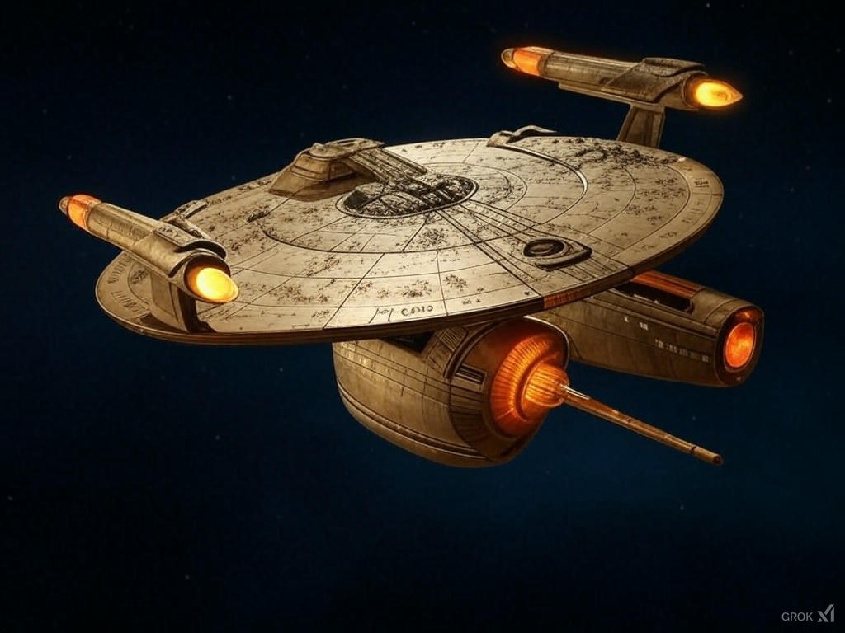

Sweet. Could you mix in some toxic looking green in the engines, and some amber dangerous looking weapons?

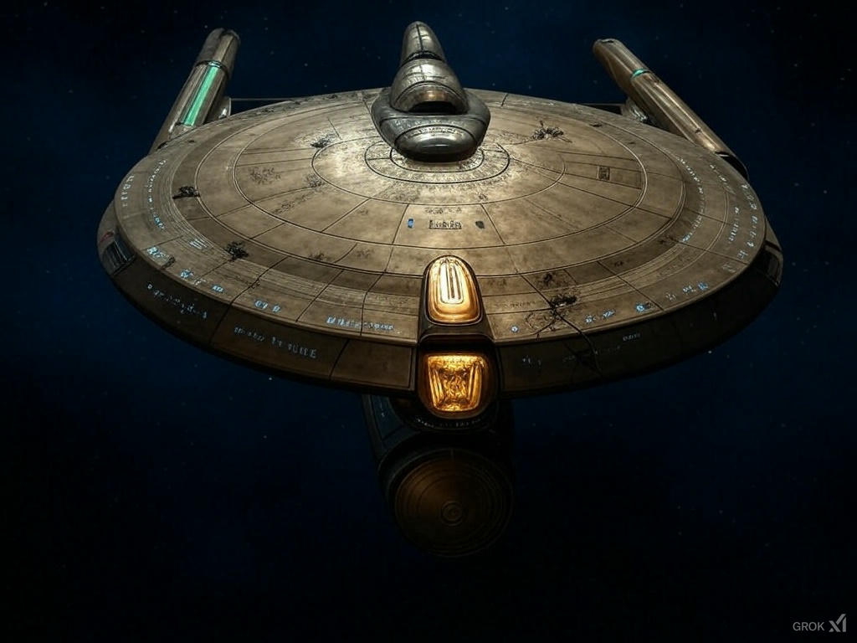

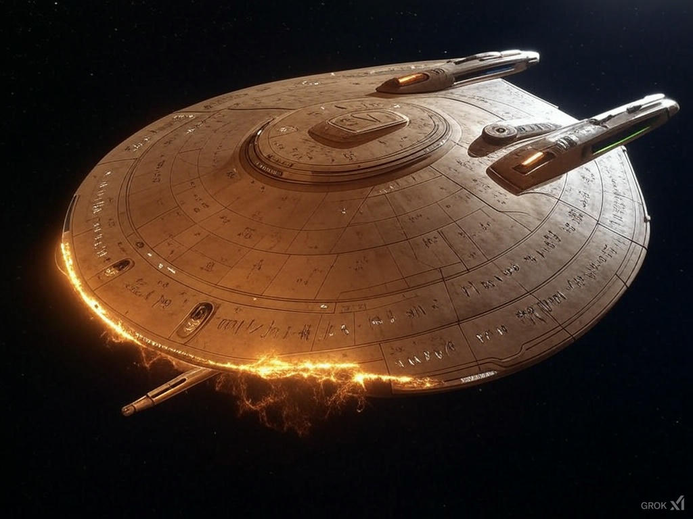
corrosive emerald engines

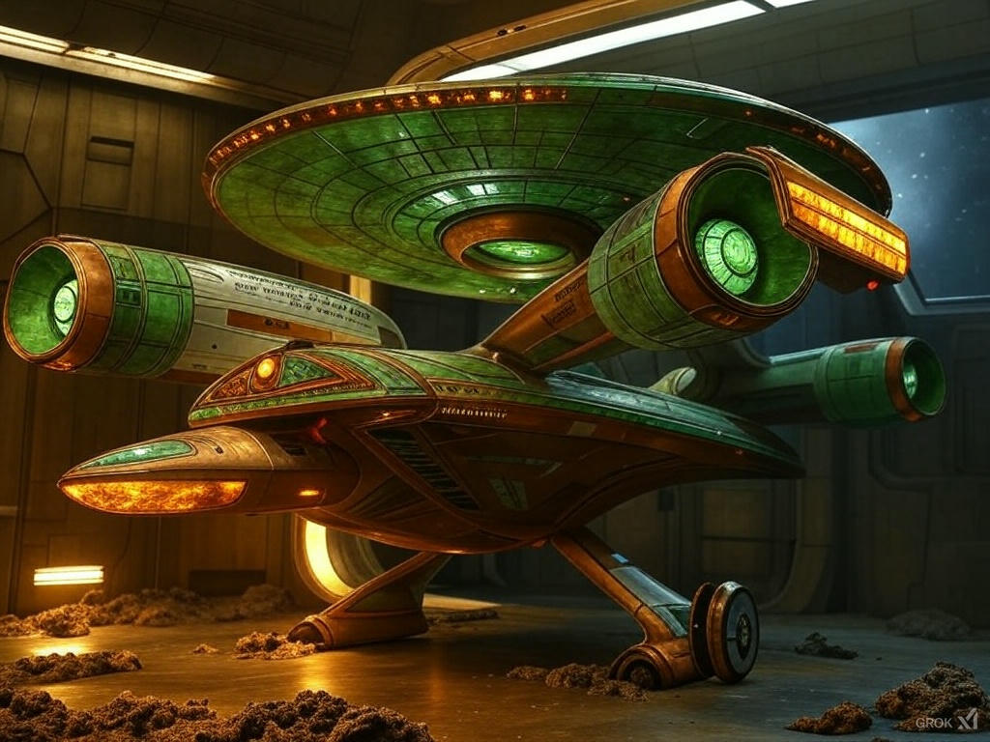

OK, add damage, like it was in a massive battle and is getting shot with the shields resisting in amber flashes?

Creating the outside view of your starship—let’s call it the Saul’s Vanguard with its bronze hull, corrosive emerald engines, amber weapons, failing shields, and Millennium Falcon-style gear—involves two main steps: modeling and texturing it in Blender, then importing and setting it up in Godot for that Starfleet Command-style 3D top-down diagonal view. Since you’re starting fresh, I’ll keep it beginner-friendly and focused on your vision. Let’s break it down.

Step 1: Modeling in Blender

Blender’s free, powerful, and perfect for your ship. Here’s how to get started:

Setup

- Download Blender: Grab it from blender.org (version 4.0 or later as of Feb 2025). Install and open it.
- Interface Basics: You’ll see a cube in a 3D viewport. Use the mouse wheel to zoom, middle-click-drag to orbit, and Shift+middle-click-drag to pan. Hit Numpad 7 for a top-down view to match your game’s vibe.

Rough Ship Shape

- Base Saucer:
  - Select the default cube (right-click), hit Tab to enter Edit Mode.
  - Press S then X and drag to scale it wide (like a saucer), then S+Y for depth. Keep it flat with minimal Z scaling.
  - In Edit Mode, hit Ctrl+R, hover over the top face, click once, then drag to add edge loops. This lets you tweak it into an angular, bronze-age shape later.

- Secondary Hull (Spear Tail):
  - Add a new cube (Shift+A > Mesh > Cube), position it below the saucer (G+Z), and scale it long and thin (S+Y) like a chariot yoke or spear.
  - Merge it into the saucer by selecting both (Shift+right-click), then Ctrl+J to join them into one object.

- Nacelles:
  - Add two cylinders (Shift+A > Mesh > Cylinder), scale them (S), and move them to the sides (G+X). Tilt them back (R+X`) like wings for that predatory look.
  - Extrude the ends (E) to make them spear-like, matching Saul’s warrior vibe.

Details

- Damage: In Edit Mode, select faces (3 key for face mode), hit Ctrl+T to triangulate, then Alt+J to clean up quads. Use the Knife tool (K) to cut cracks, then G to pull vertices for dents.
- Equipment: Add simple shapes—cube for a scanner, cone for a dish (Shift+A > Mesh > Cone)—and scatter them on top. Scale and rotate (S, R) for that cluttered Falcon feel.
- Angle It: Rotate the whole model (R+X+45) to preview that diagonal view.

Texturing (Basic)

- UV Unwrap: In Edit Mode, select all (A), hit U > Smart UV Project. This flattens your model for painting.
- Materials:
  - In the Material Properties tab (bottom-right sphere icon), click “New.” Name it “Bronze.”
  - Set Base Color to a dark bronze (#8C5523). Add a Metallic value (0.8) and Roughness (0.4) for that hammered look.
  - Add a second material for engines, set Base Color to toxic green (#00FF66), and crank Emission to 1.0 for a corrosive glow.
  - Add a third for weapons, Base Color amber (#FFBF00), with slight Emission (0.5).

- Assign: In Edit Mode, select nacelle faces, click the green material, and hit “Assign.” Repeat for weapons.

Export

- Select your ship, go File > Export > glTF 2.0 (.glb). Save it as “SaulsVanguard.glb.” This format plays nice with Godot.
Time: 5-10 hours for a rough version if you’re new. Watch a Blender beginner tutorial (e.g., Blender Guru’s donut) for basics.

Step 2: Setting Up in Godot

Godot’s a free game engine that can handle your 3D top-down view. Here’s how to bring your ship to life:

Setup

- Download Godot: Get it from godotengine.org (4.2 or later as of Feb 2025). Open it and create a new project (“SaulsVanguardGame”).
- Scene Basics: Start with a 3D scene (+ > Node3D). This is your root.

Import Ship

- Drag “SaulsVanguard.glb” into your project’s file system (bottom-left).
- Add it to the scene: + > MeshInstance3D, click its Mesh property, and pick your .glb file. It’ll appear in the 3D viewport.

Camera Angle

- Add a Camera3D (+ > Camera3D). Position it above and behind the ship (G+Z+10, G+Y+-5).
- Rotate it down 45° (R+X+-45) for that Starfleet Command diagonal view. Use the preview (top-right corner) to tweak.

Shields & Effects

- Shields: Add a MeshInstance3D, use a Sphere mesh, scale it to fit the ship. In its material, set Albedo to amber (#FFBF00), Transparency to 0.5, and toggle “Unshaded” for a glow. Animate it flickering:
  - Add an AnimationPlayer node, create a new animation (“ShieldFail”), keyframe the Transparency from 0.5 to 0.1 over 1 second, loop it.

- Damage: For now, rely on your Blender damage. Later, swap meshes in Godot for worse states.

Test It

- Hit F5 to run. Use WASD or a simple script to move the ship (Node3D > func _process(delta): translate(Vector3(Input.get_axis("ui_left", "ui_right"), 0, Input.get_axis("ui_up", "ui_down")) * delta * 5)). Does it feel alive?
Time: 2-5 hours to get it moving, more for effects.

Next Steps

- Polish in Blender: Add rivets, runes, more gear. Sculpt damage deeper. Paint textures in Blender or Substance for grit.
- Godot Gameplay: Script shield health (decrease on “hit,” flicker faster), add enemy shots (ParticleSystem3D), and test upgrades (swap meshes).
- Learn as You Go: Blender’s UI is a beast—focus on one tool at a time (e.g., extrude, scale). Godot’s nodes click fast once you grasp them.
You’ve got a ship with bronze grit, emerald engines, amber weaponry, and a battle-worn soul. Start with the saucer in Blender, import it to Godot, and tweak that camera. What part sounds most fun to tackle first—modeling the hull or setting up the scene? I can dive deeper wherever you point!

